Lab: HTTP Basics

Installing Needed Software

Postman
You can download Postman from here.
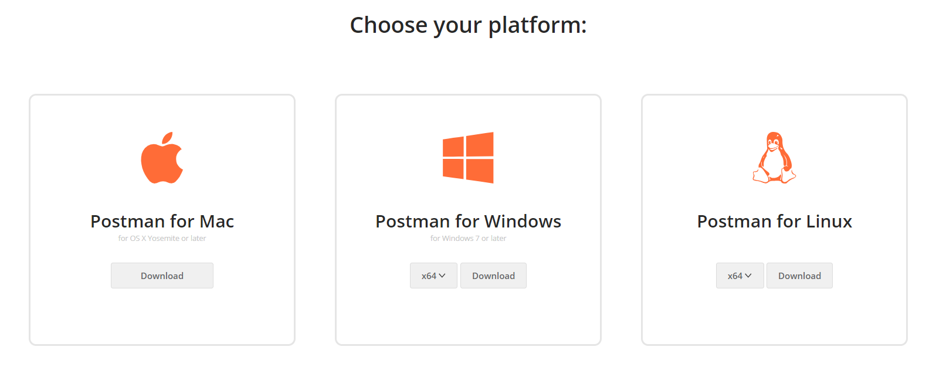

Make Basic HTTP Requests

Get All Trips
Listing all trips should be easy with the following request:
https://trips-48955.firebaseio.com/trips.json
Request: 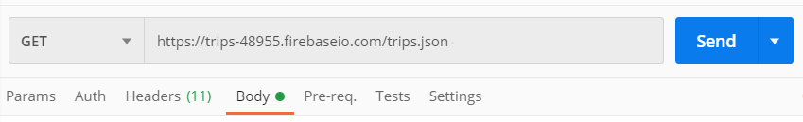
Response: 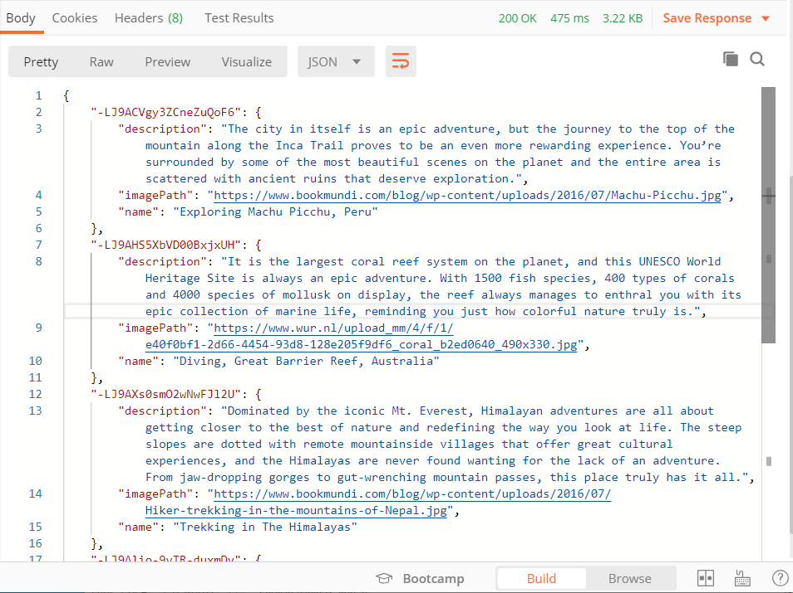

Create New Trip
Let's make a "POST" request to add a new destination to our firebase database. Use the following data:
{
"description" : " October-November and February-March are the best times to see the northern lights. Dark skies yield better displays – avoid full moon. ",
"imagePath" : "https://www.aurora-nights.co.uk/wp-content/uploads/2019/07/norway-northern-lights-1500x587_c.jpg",
"name" : "Capture the Northern Lights on camera"
}
Request:
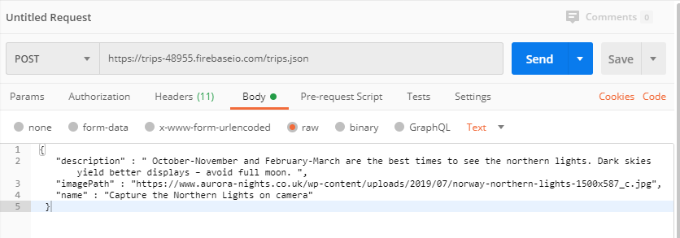
Response:
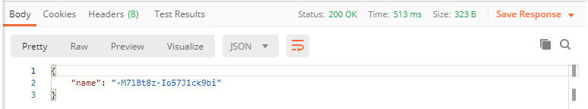

Delete a Trip
Now let us delete the newly created trip.
REQUEST "DELETE": https://trips-48955.firebaseio.com/trips/{postId}.json. The postId can be found from the JSON response of the previous task:
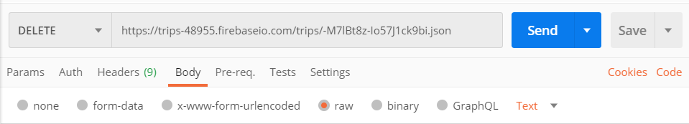
The "DELETE" request should get us status 200 and the default response from this database is null:
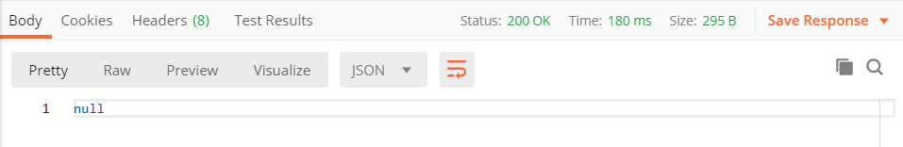
Now, when we get all trips, we can notice that the trip "Capture the Northern Lights on camera" is not on the list.

Edit a Trip
Edit a trip with a "PATCH" request.
https://trips-48955.firebaseio.com/trips/-MIJ0HydEYF0x6fljO55.json
We will update the: "Pyramids of Giza, Egypt" trip by changing the "description" and adding the new field "edit": "true" using the following body:
{
"description" : "Egypt welcomes you!",
"imagePath" : "https://www.karacitours.bg/public/thumbs/767x341/egipet/egipet-4_767x341_crop_542eb8694d.jpg",
"name" : "Pyramids of Giza, Egypt",
"edit": "true"
}
Request:
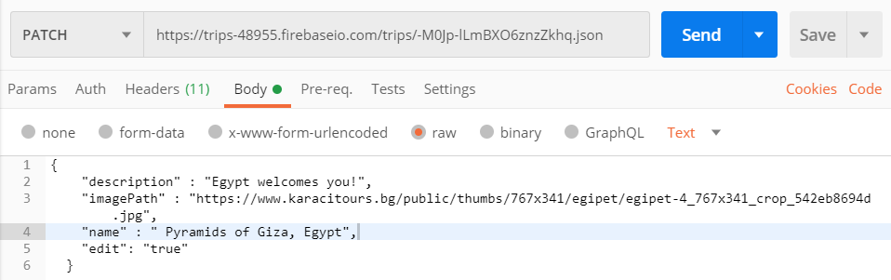
Response:
